

**KHULNA UNIVERSITY OF ENGINEERING AND TECHNOLOGY**

**KHULNA**

**Department of Computer Science and Engineering**

**Date: 03.07.2019**

**Course No: CSE 3103**

**Course Name: peripherals and Interfacing Laboratory**

**Project Name: Arduino Control Smart Robotic Hand**

**Submitted To:**

* **Dr. Muhammad Sheikh Sadi**
  + **Professor**
  + **Dept. of CSE, KUET**
* **Md. Milon Islam**
  + **Lecturer**
  + **Dept. of CSE, KUET**

**Submitted By:**

**Nazmus Shakib Riad**

**Roll: 1607096**

**Dept. of CSE, KUET**

**Ashikur Rahaman**

**Roll: 1607098**

**Dept. of CSE, KUET**

**Objectives:**

The objective of this project is to

• Automate the process of drilling, cutting and cleaning using robotic arm.

• Use of robotic arm in small areas of work.

• Synchronizing robotic technology and android system.

**Introduction:**

In the modern world, Robotics has become popular, useful, and has achieved great success in several fields of humanity. Robotics has become very useful in medicine, education, military, research and mostly, in the world of manufacturing. It is a term that has since been used to refer to a machine that performs work to assist people or work that humans find difficult or undesirable.

The equipment used in automation are effective to produce at faster rates and with better quality. Automation is made by using different machines like CNC (Computer Numerical Control), putting conveyors for transfer systems. All these systems require PLC (Programmable Logic Controller). Also most of the automobile industries use robots. Robots are used for making spot welding, painting, assembly, water-jet cutting, dispensing, handling parts. By using robots work is completed faster. Accuracy of work increases because robot works as per the program stored in it. There is no deviation in the position from programmed points. As software used in the robot is advanced the diagnosis is also very easy and faster.

In this project, work is carried out on the robotic arm which is controlled using an Arduino micro-controller through an android app. It is applicable for drilling, pick and place, cutting and cleaning applications. The benefits of this work are visual movement of the device, text-to-speech recognition, compact in size and economical. It is also capable of carrying out operations which are difficult for the humans to perform.

**Block Diagram:**

Block diagram of our proposed system I given below:

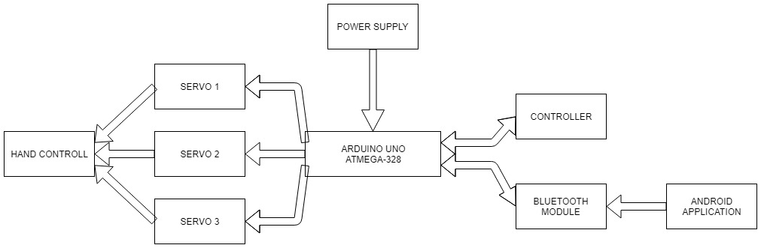

**Fig 1: Block Diagram of Arduino control smart robotic arm**

**Flowchart:**

Flowchart of the system will be like this:

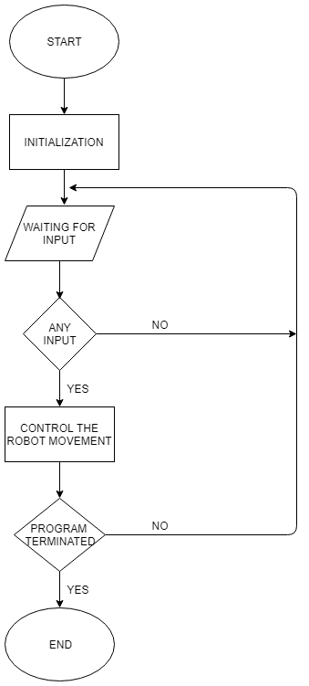

**Fig 2: Flowchart of Arduino control smart robotic arm**

**Pseudo-code:**

Here is the pseudo-code for the software design of the system:

Servo_1, servo type global variable 1

Servo_2, servo type global variable 2

Servo_3, servo type global variable 3

Joy_X := 0, integer type global variable 4

Joy_Y := 1, integer type global variable 5

Serval, integer type global variable 6

function setup ()

attach servo_1 to pin 3

attach servo_2 to pin 5

attach servo_3 to pin 6

write servo_1 at 50

write servo_2 at 100

write servo_3 at 100

begin serial monitor at 9600

end function setup

function loop ()

if(serial.available()) greater than zero

data, character type variable

read serial input and store into data

if(data=’h’)

for(i from 240 to 80)

write (i) value in servo_3

break

end of for loop

if(data=’d’)

for (i from 80 to 240)

write (i) value at servo_3

break

default : break

Serial monitor print(data)

Delay generate (50)

servoVal = analogRead from (joyX)

servoVal = map(servoVal, 0, 1023, 50, 180)

servo_1 write at (servoVal)

servoVal = analogRead from (joyY)

servoVal = map(servoVal, 0, 1023, 50, 150)

servo_2 write at (servoVal)

delay generate (0)

End function loop

**Hardware design:**

Hardware equipment that we need in order to build the project is given below:

* Arduino Uno
* Joystick
* Servo motor
* Bluetooth module
* Bread-board
* Power supply
* Wood stick
* Glue
* Card board
* Connecting wire(As required)

Using these apparatus we have constructed this circuit diagram below:

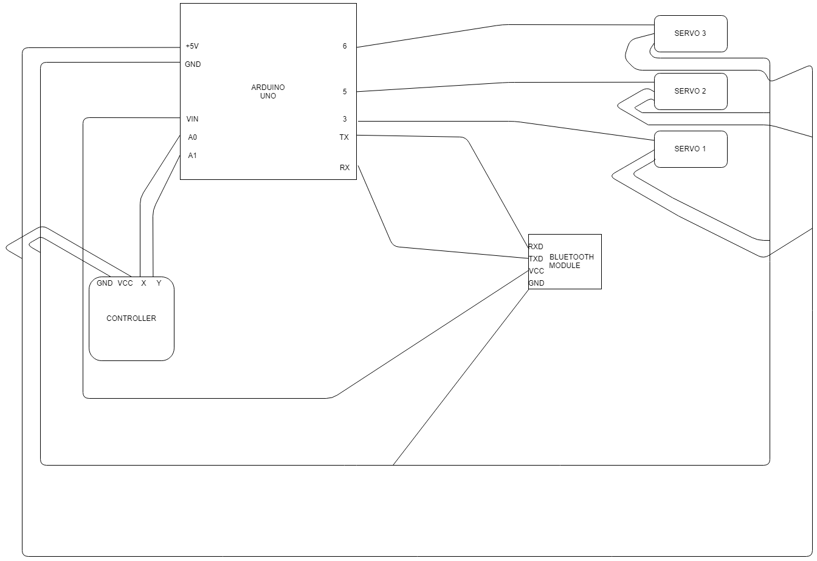

**Fig 3: Hardware design of Arduino control smart robotic hand**

**Prototype design & implementation:**

We have designed the prototype for the Arduino control smart robotic arm system in fig.4, the servo 1 control the arm, the servo 2 control the neck and the third servo control the grabbing part. So the arm can move easily

Now, from the designed figure we have implemented a real prototype of the system where wooden stick is being used as arm and some special wiring is used to grab a particle. Also we have used joystick controller and Bluetooth to control it. In figure 5 the shows the build prototype of the system.

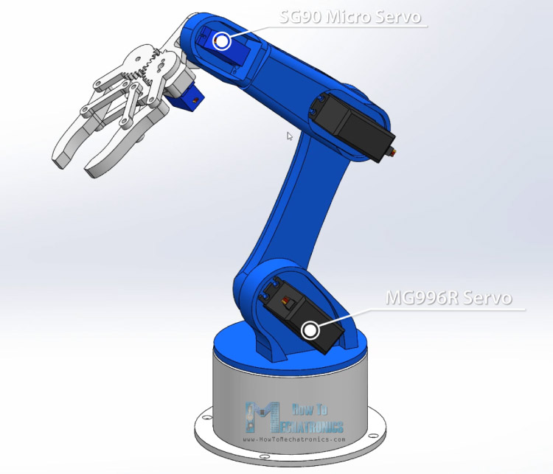

**Fig 4: Prototype design of Arduino control smart hand**

**System Testing:**

We have tested the design system with joystick control system. The testing result we have found are:

1. When we move the joystick controller upward the servo_1 moves at 150 degree and the hand goes upward.
2. When we move the controller downward the servo_1 moves at 30 degree and the hand goes downward.
3. At the time of moving right and left the servo_2 moves 90 degree each side.
4. By using android app servo_3 is controlled to grab something.

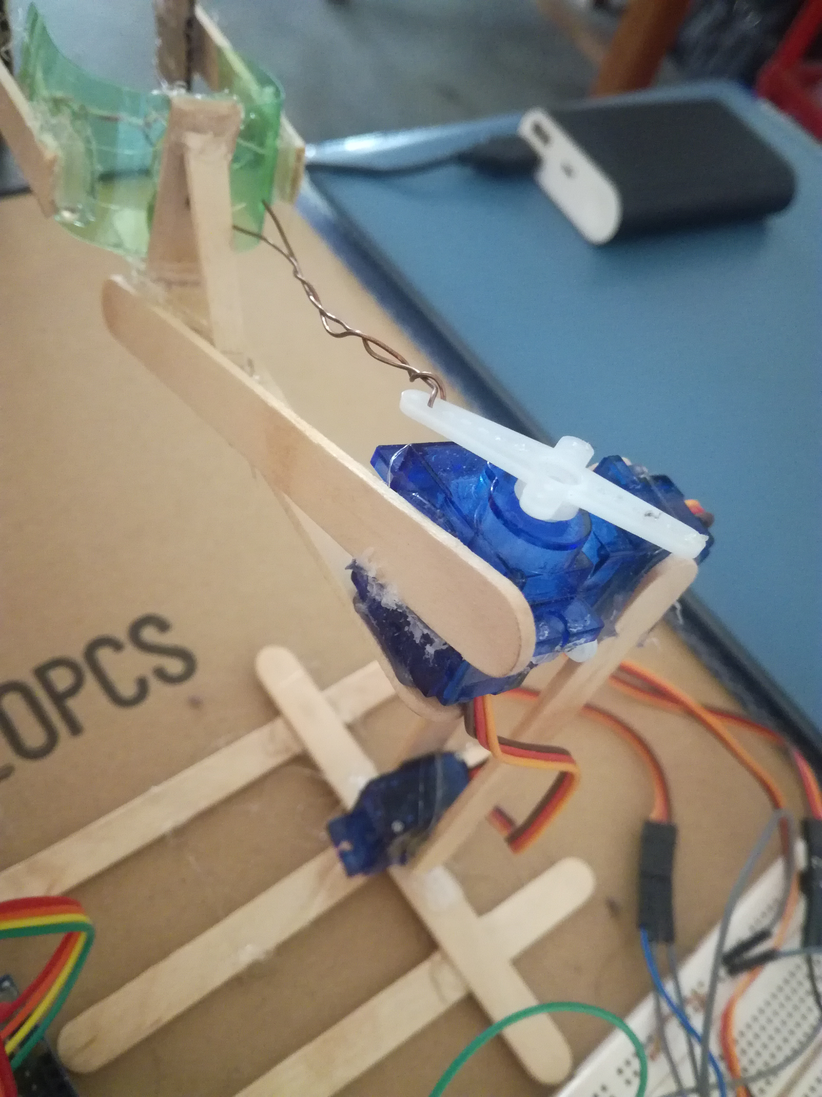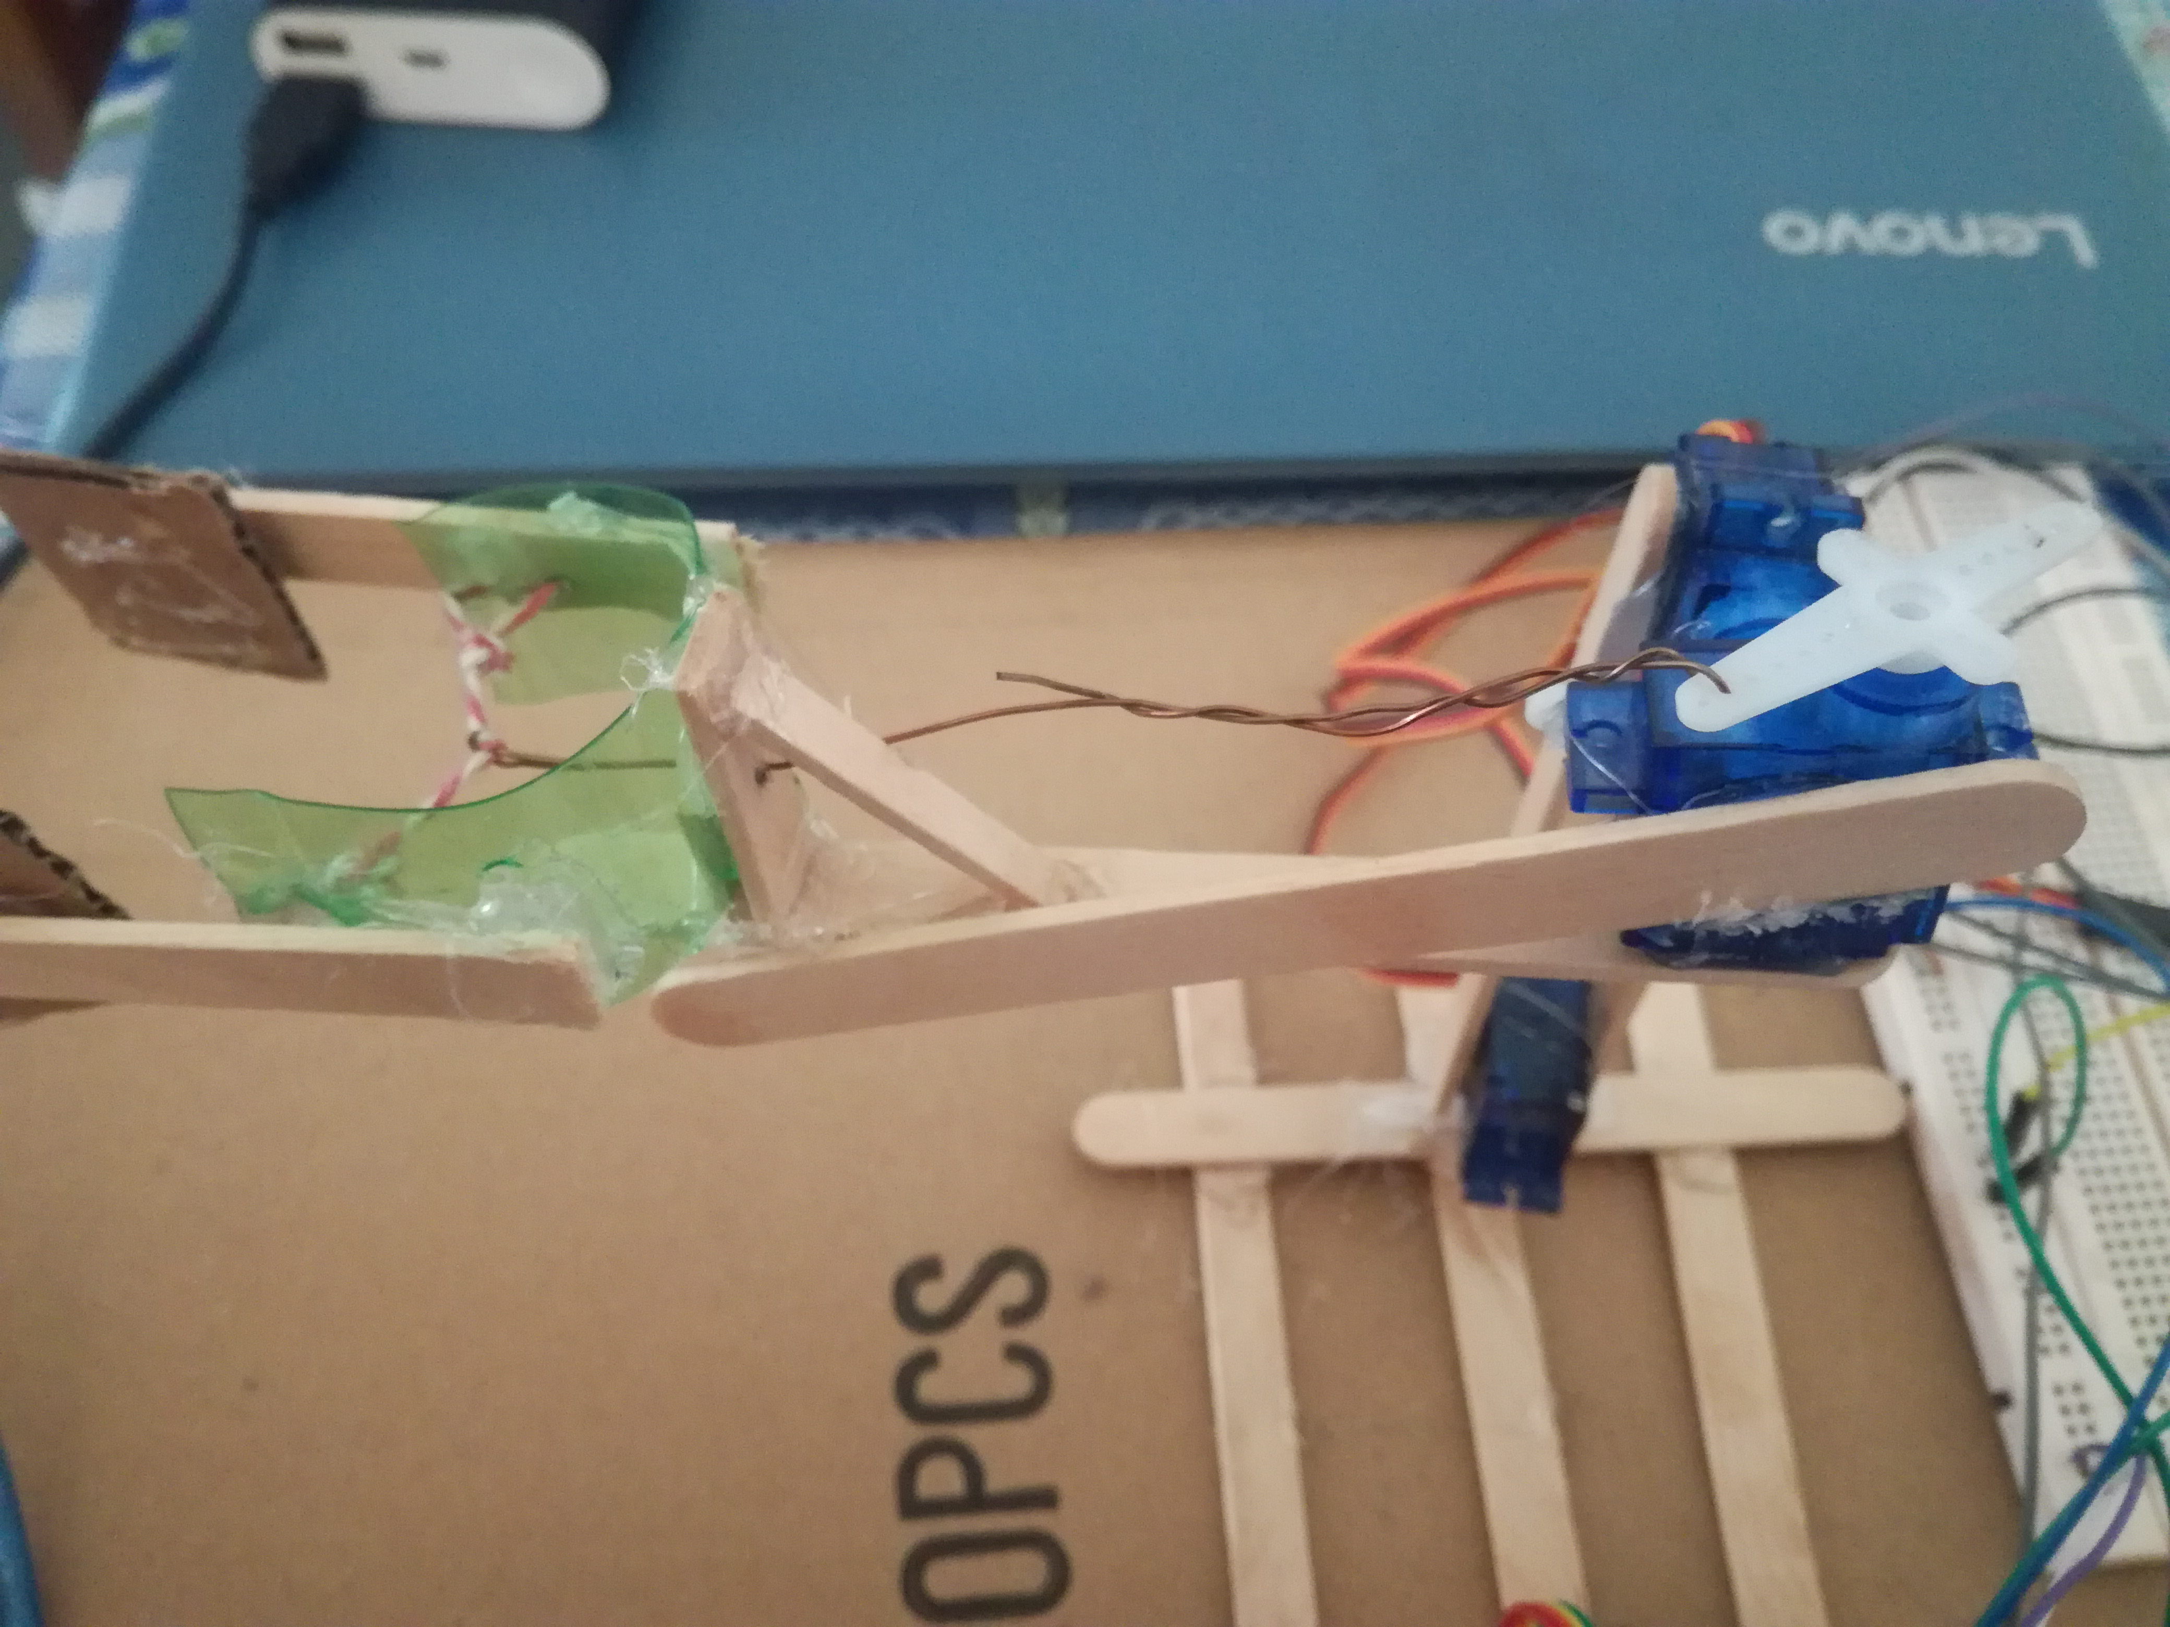

**Fig 5:Top view of the protype**

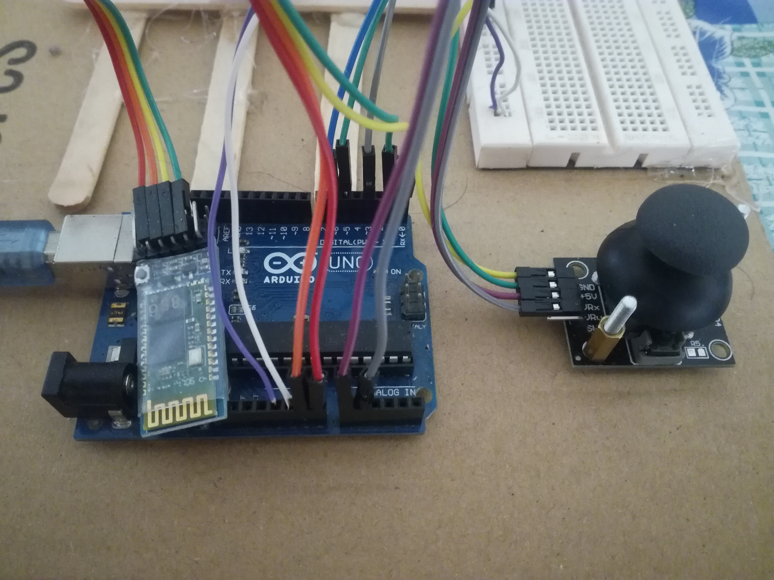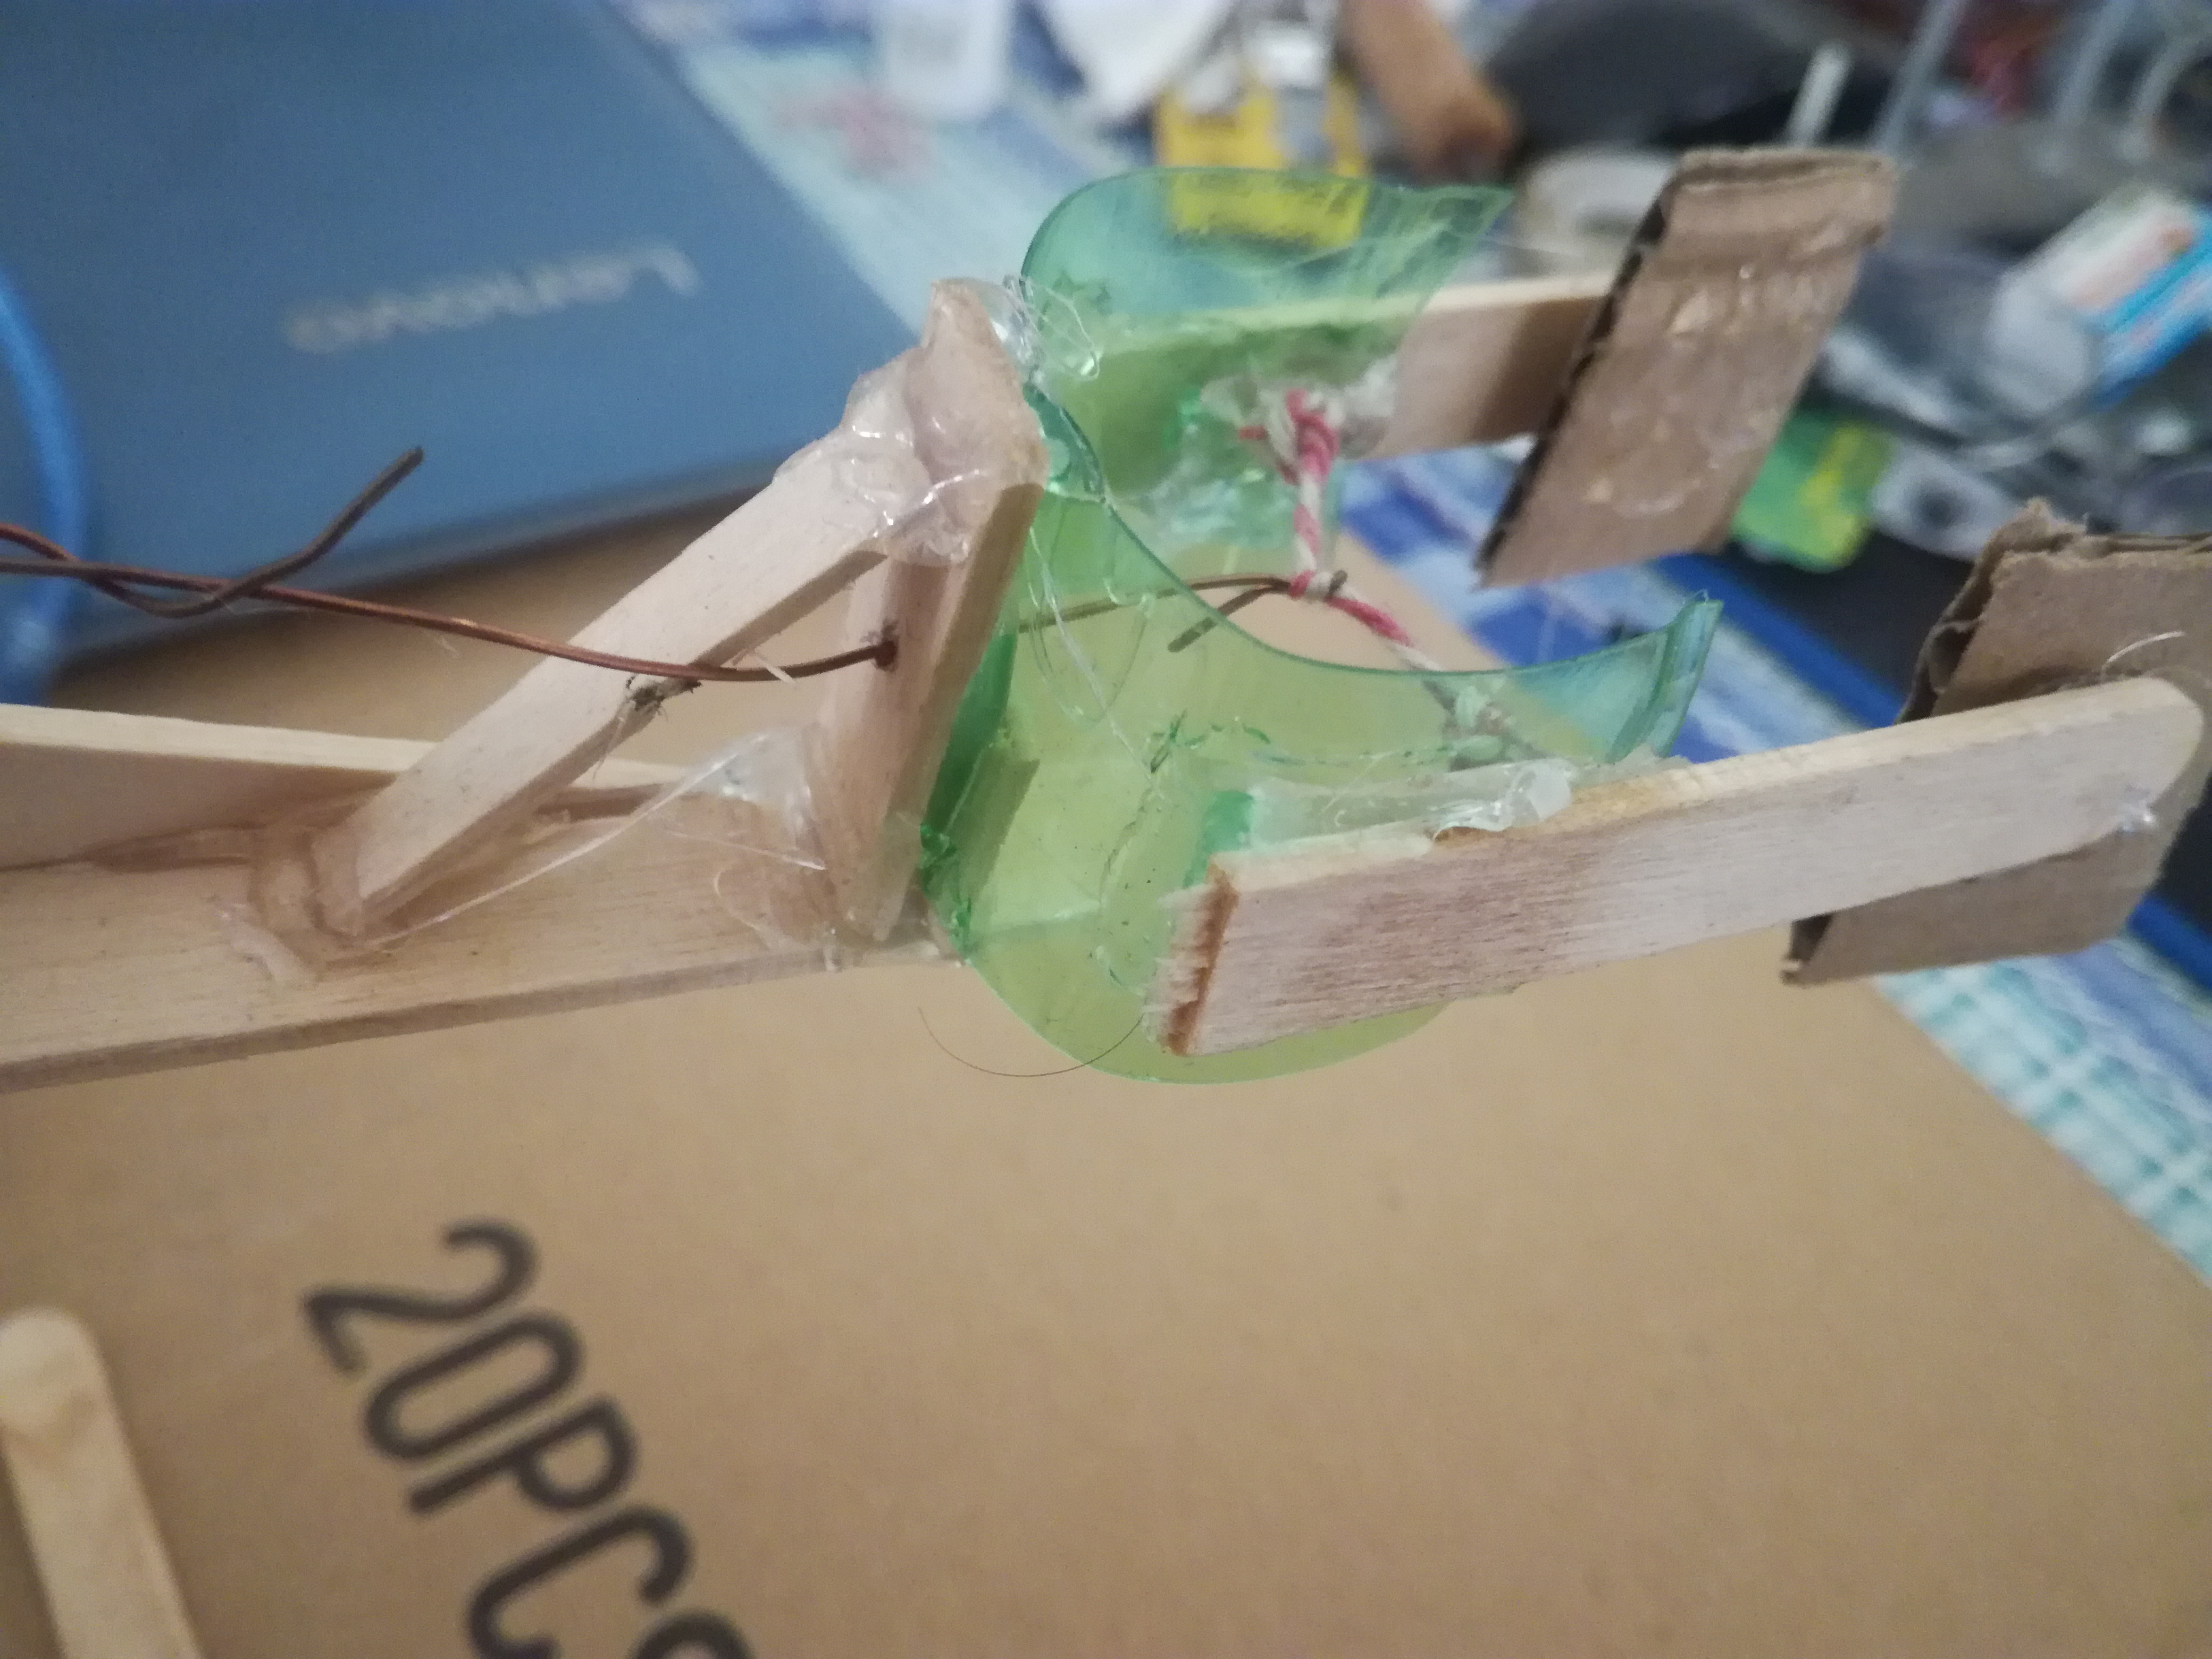

**Fig 6: Bluetooth module and controller is used to move the hand and grab**

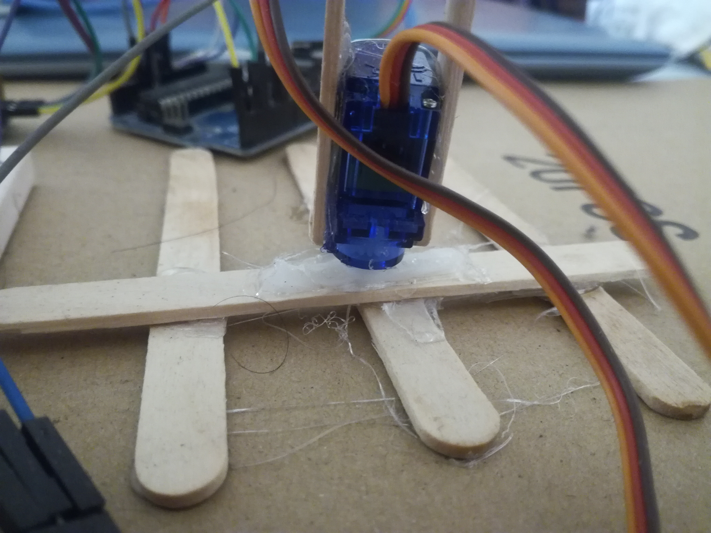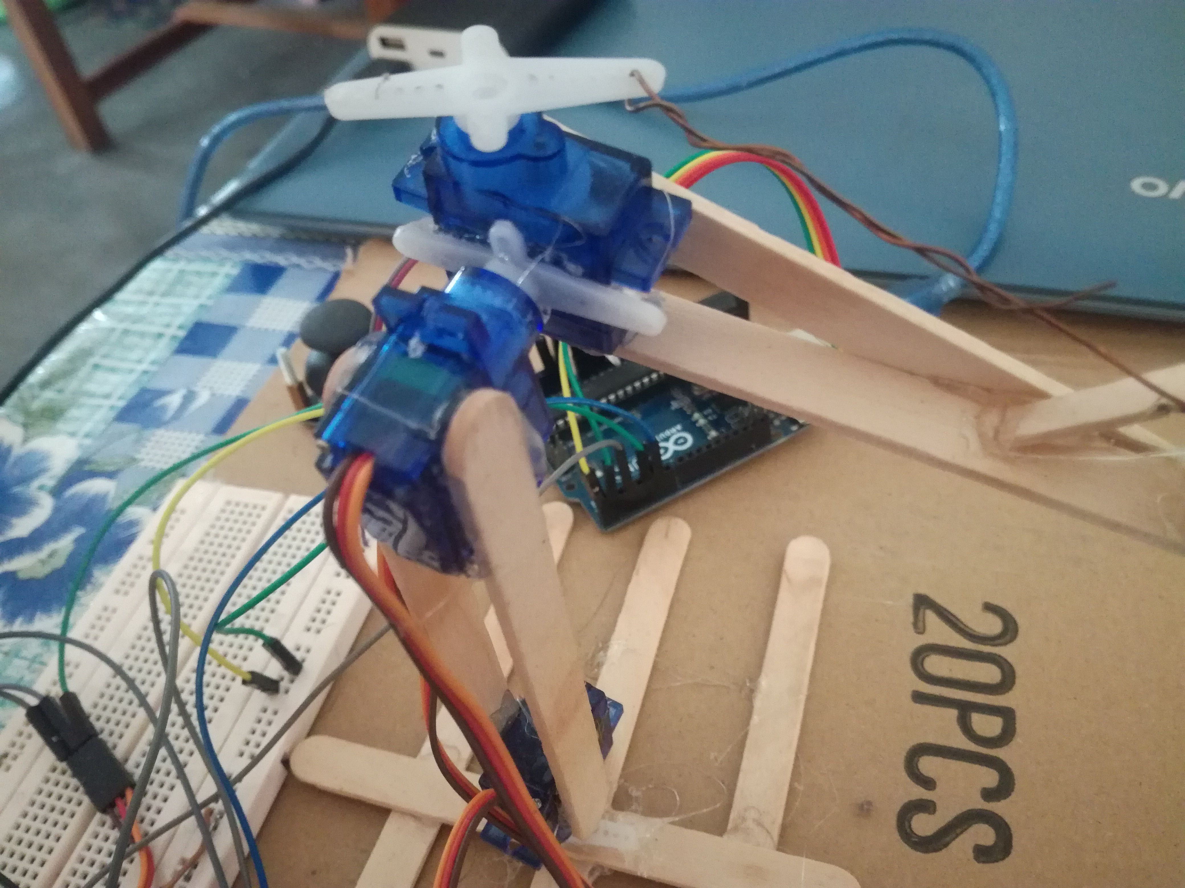

**Fig 7: Servo-motor connection part**

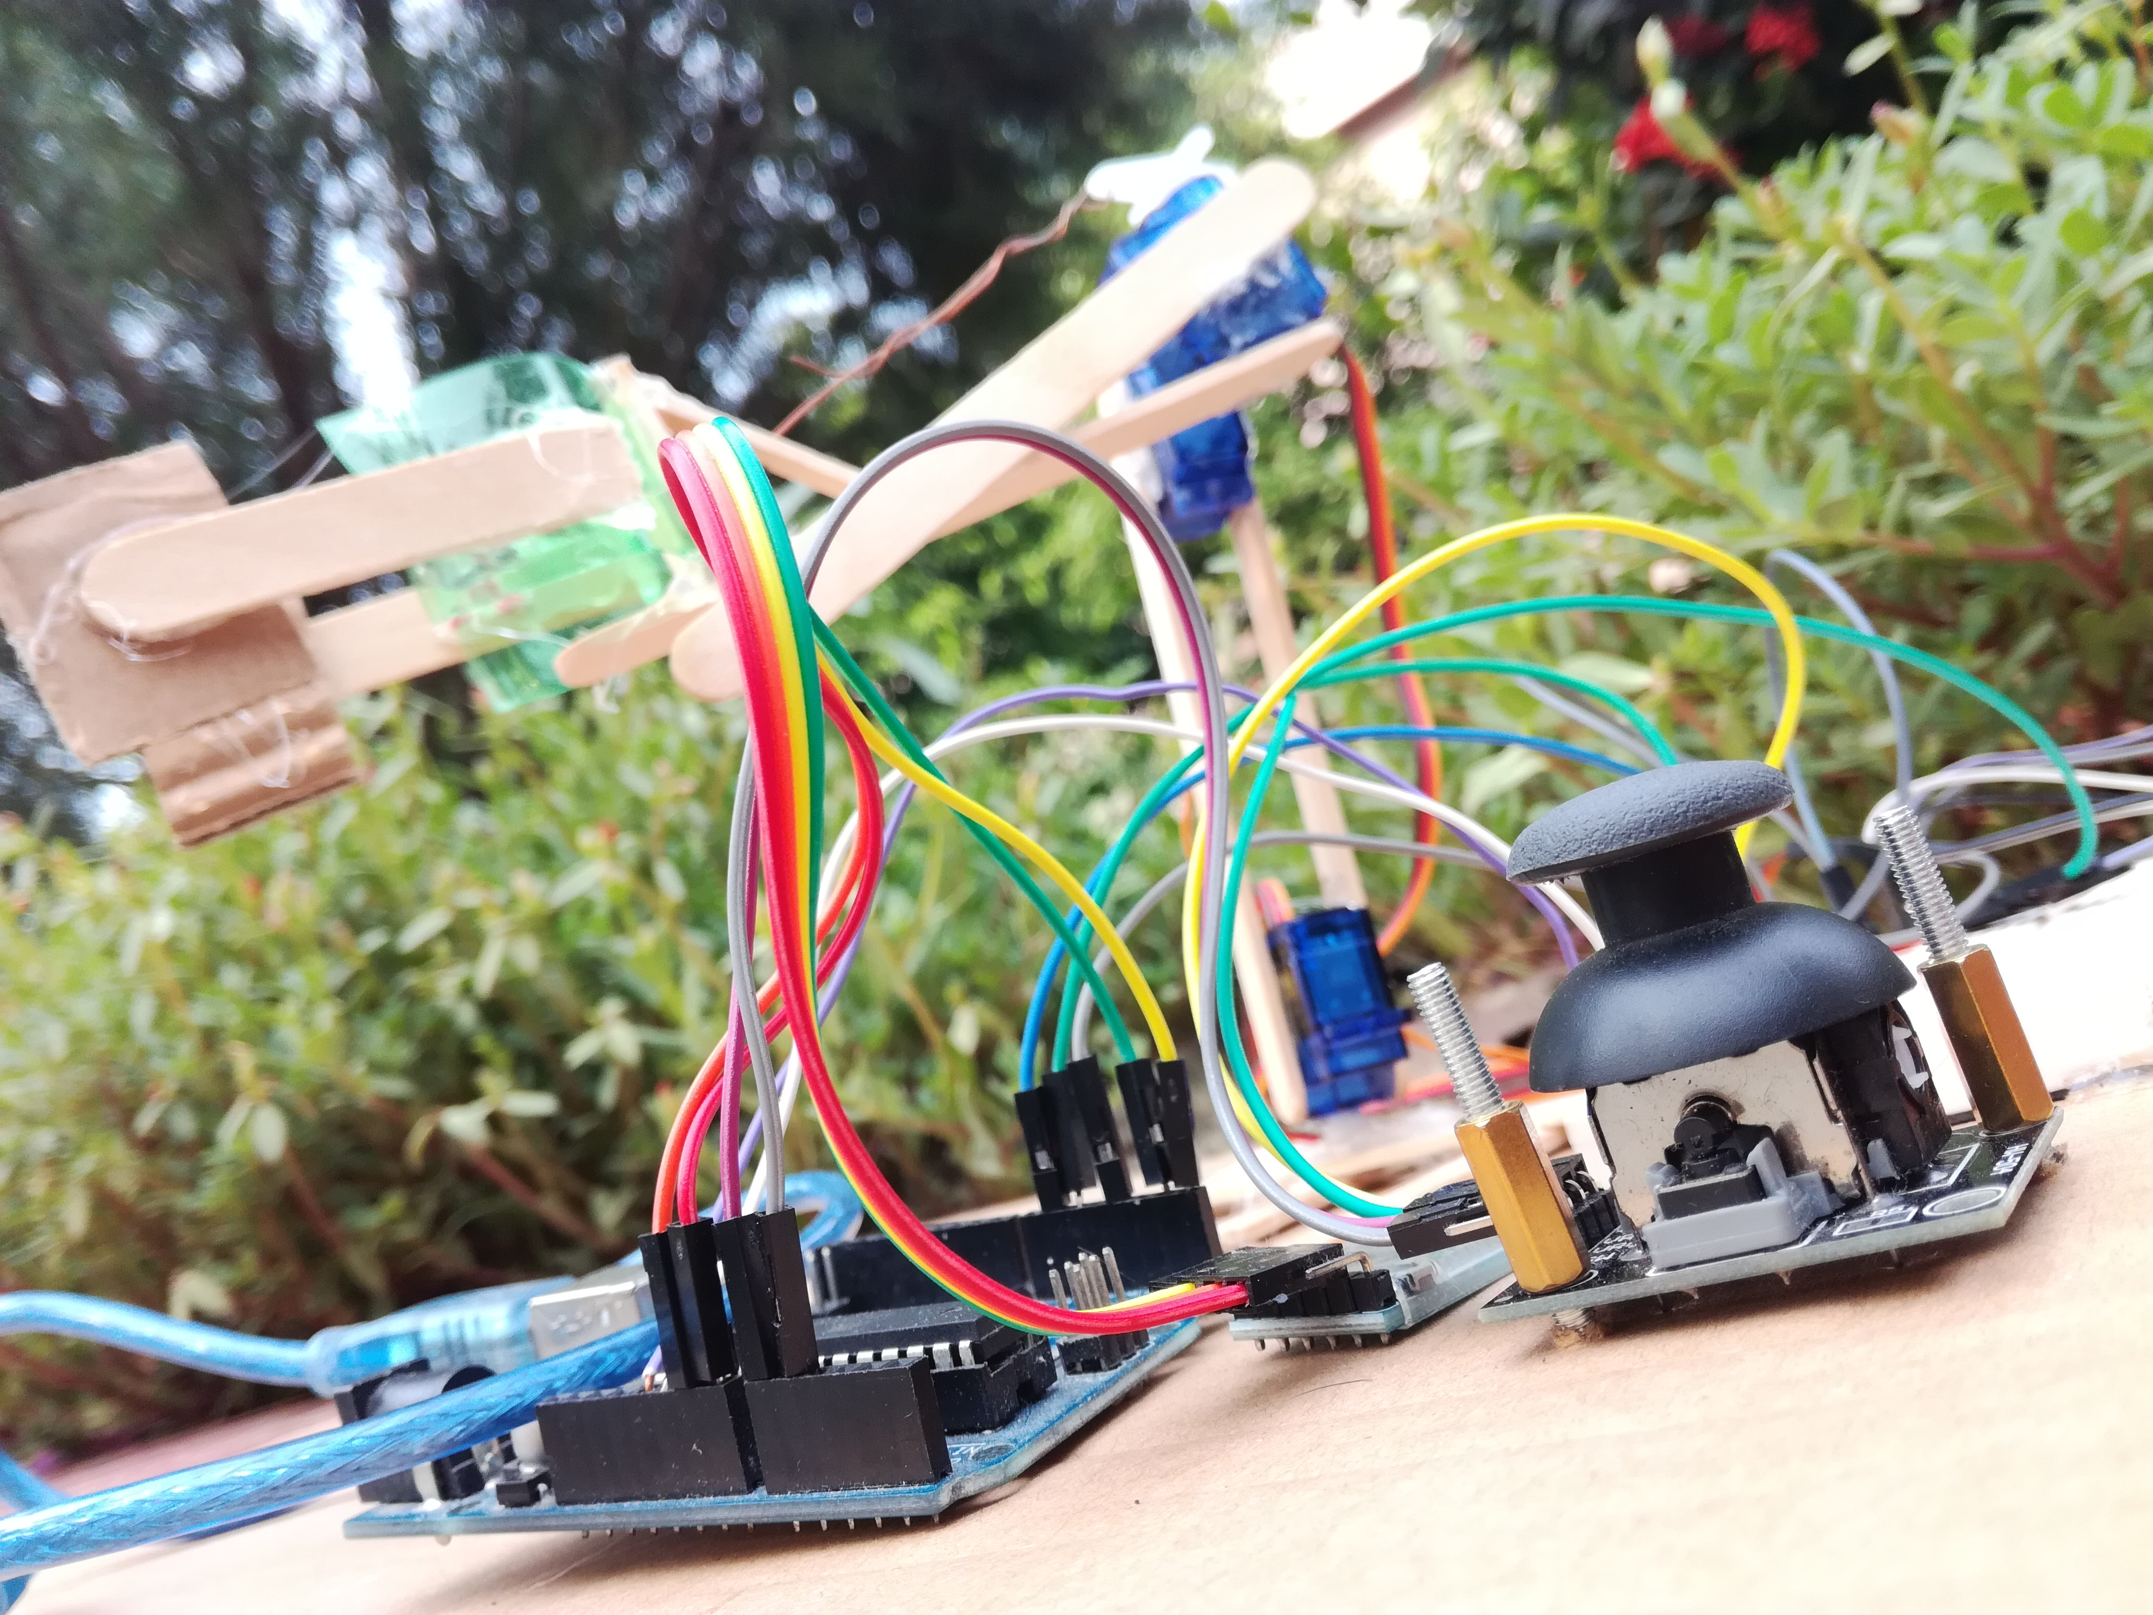

**Fig 8: Full prototype**

**Experimental Result:**

We have experimented the system to gather some statistical result. After the experience,

We have found that the rotating speed of servo1 is 10.71 degree per second and the servo2 was rotating faster than the servo1 with the speed of 14.56 degree per second. As the servo motors can rotate no more than 180 degree, so if we applied an input to rotate the hand to a direction that the hand would rotating continuously, the hand eventually stopped rotating after 90 degree in both sides.

**Discussion:**

In this project, an Arduino control smart robotic hand was built in order to increase the working capability of man. It moves by the direction given by its controller. The rotating speeds of the hand in four directions were found satisfying and the holding capability of something is very good. But as a servo motor cannot move no more than 180 degree, there were found some restrictions to rotate the hand to go in particular position.

**Conclusion:**

The report has presented a novel and a simple control implementation of a smart Arduino control hand that employed by three servo motor to follow the joystick direction and android based application.

A laboratory prototype has been successfully built and tested to verify the effectiveness of the control implementation. Experiment results indicated that the developed system increased the working capability of human.

**References:**

* <https://www.mdpi.com/2076-3417/10/1077/pdf>
* <https://www.arduino.cc/reference/>
* <https://pdfs.sematicscholar.org/f27d/81c4e0c5c941ad9fd3a06589a9abb9c0b1a4.pdf>